**<SPARK AIRWAYS>**

**Project Abstract**

**Version 1.0**

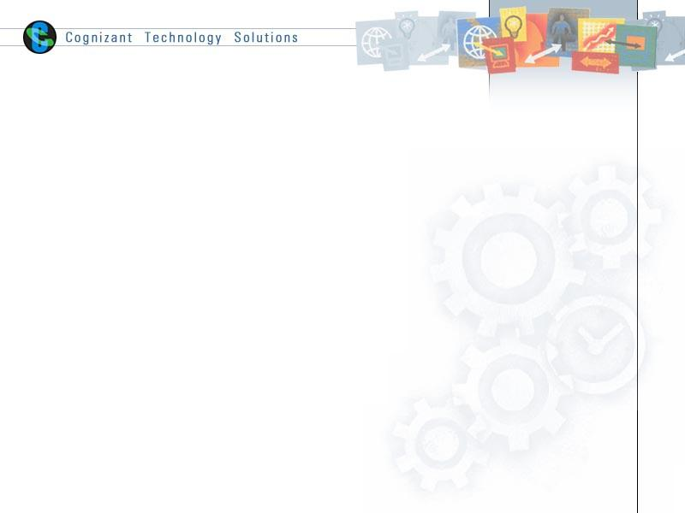

|  |  |  |  |
| --- | --- | --- | --- |
|  | **Prepared By / Last Updated By** | **Reviewed by** | **Approved By** |
| **Name** | <POD to fill>  Abhay Raj Singh (904045)  Anshuman Sahu (904740)  Bhavesh Saini (904730)  Nikhil Kharwal (904927)  Siddharth Sharma (904965) | <Trainer/Project Governance Representative/Cohort Mentor to fill> | <Trainer/Project Governance Representative/Cohort Mentor to fill> |
| **Role** |  |  |  |
| **Signature** |  |  |  |
| **Date** |  |  |  |

**Table of Contents**

**1.0** **Purpose of this document 4**

**2.0** **Business Case 4**

**3.0** **Appendices 4**

**3.1** **Glossary 4**

**3.2** **Other 4**

**4.0** **Terms & Conditions 5**

**5.0** **Change Log 5**

# Purpose of this document

This document provides an overview about the business need and the solution that can be provided to fulfil the objective.

# Business Case

## 2.1 Project overview

## Spark Airways is an online flight ticket booking web application. Through it users will be able to book ticket for flight from some source to a destination. They will be responsible for paying for the ticket. And will be able to see all the past booking history. New users can also sign up. Admin will be responsible for adding new flight and scheduling them. And they will be able to view all user information and all bookings.

The objective of the project is to design an Airline Reservation System web application which enables the customers to search and book flights. The project has been designed in Java technology and consists of a MySQL which acts as the database for the project.

This project has two parts. First is the user part and the administrator part. User part is used as a front end and administrator is the back end. Administrator is used by airline authority. It will allow new customers to sign up for online access.

The system allows the airline passenger to search for flights that are available between the two travel cities, namely the “Departure city” and “Arrival city” for a particular departure and arrival dates. The system displays all the flight’s details such as flight no, name, price.

After searching the system displays a list of available flights and allows customers to choose a particular flight. Then the system checks for the availability of seats on the flight. If the seats are available, then the system allows the passenger to book a seat. Otherwise it asks the user to choose another flight.

 To book a flight the system asks the customer to enter his details such as name, address, city, state, and credit card number and contact number. Then it checks the validity of the card and book the flight and updates the airline database and user database. The system also allows the customer to cancel his/her reservation, if any problem occurs.

The main purpose of this application is to reduce the manual errors involved in the airline reservation process and make it convenient for the customers to book the flights as when they require such that they can utilize this application to make reservations, modify reservations or cancel a particular reservation.

<POD to fill>

# Appendices

## Glossary

|  |  |
| --- | --- |
| **Acronyms** | **Definitions** |
|  |  |

## Other

# Terms & Conditions

***Disclaimer: Please do not circulate or distribute this document outside of Cognizant Network, we have a Zero Tolerance Policy. Kindly adhere to 100% Compliance at all times.***

# Change Log

*Please note that this table needs to be maintained even if a Configuration Management tool is used.*

|  |  |  |  |  |
| --- | --- | --- | --- | --- |
| **Version Number** | **Changes made** | | | |
| V<n.n> | *<If the change details are not explicitly documented in the table below, reference should be provided here>* | | | |
| Page no | Changed by | Effective date | Changes effected |
|  |  |  |  |
|  |  |  |  |
|  |  |  |  |
|  |  |  |  |